Farewell Programme Organised for Outgoing Sixth Semester Students

Under the able guidance of Prof. Suresh Kumar Dogra, the Student Council of the college, under the instructions of the College Debates and Seminar Committee, organised a grand Farewell Programme for the outgoing Sixth Semester students on 11 May 2026 in the college auditorium. The event was marked by warmth, gratitude, cultural vibrancy, and emotional reflections, making it a memorable occasion for both senior and junior students.
The programme commenced with a formal welcome of the dignitaries, faculty members, and students. The beautifully decorated venue, coupled with enthusiastic participation from students, created an atmosphere of celebration and nostalgia.
Addressing the gathering, Principal Prof. Suresh Kumar Dogra extended his heartfelt wishes to the outgoing students for a bright, successful, and purposeful future. In his inspiring address, he appreciated the junior students for organising the farewell with great dedication and affection as a mark of respect and gratitude towards their seniors. He remarked that such occasions strengthen the bonds of camaraderie, mutual respect, and institutional belonging among students.
Using the occasion to address an issue of immense social concern, the Principal also spoke extensively about the alarming rise in drug abuse among the youth. Referring to the ongoing 100-day nationwide Nasha Mukt Bharat Abhiyaan campaign, he urged students to become ambassadors of awareness, responsibility, and social reform. He emphasised the role of educational institutions in shaping morally conscious and socially responsible citizens and encouraged students to channel their energy towards constructive and creative pursuits.
The programme featured a variety of colourful cultural performances presented by junior students, including songs, poetry recitations and musical presentations, which enthralled the audience and added charm to the event. The performances reflected the creativity, confidence, and artistic talent of the students and were received with great applause.
On the occasion, several outgoing students shared their memorable experiences of college life, expressing gratitude towards their teachers, friends, and the institution for providing them with guidance, knowledge, and cherished memories. Their speeches were filled with emotion, nostalgia, and hope for the future, creating touching moments during the programme.
The event concluded with a vote of thanks delivered by the organisers, who acknowledged the support and encouragement of the college administration, faculty members, and students in making the farewell programme a grand success. The programme ended on a note of goodwill, celebration, and emotional bonding, leaving behind lasting memories for the graduating students as they prepare to embark upon a new journey in life.

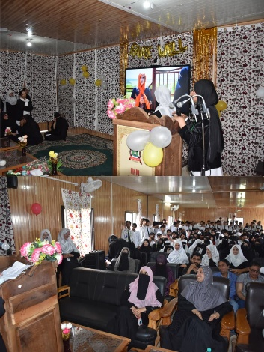
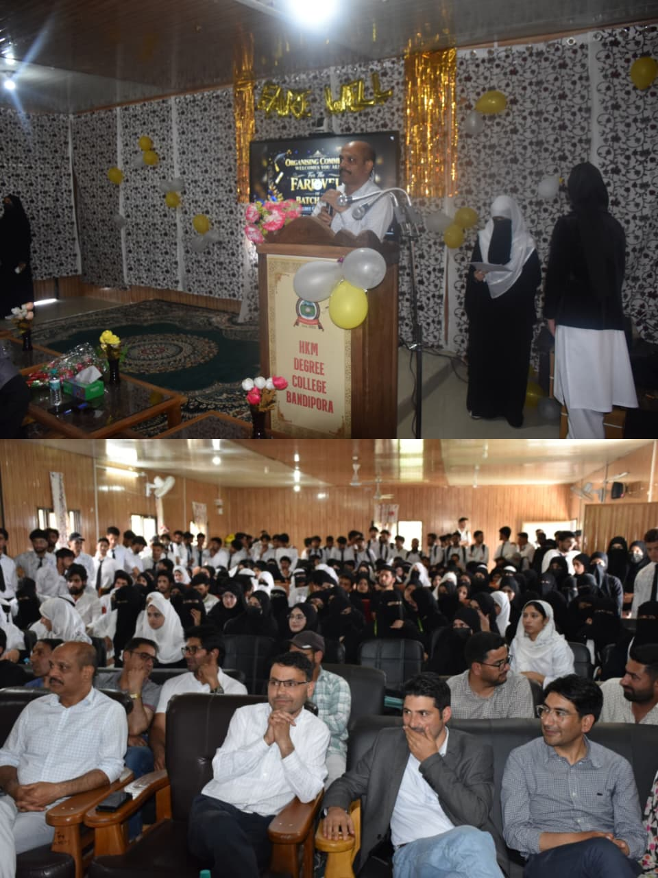
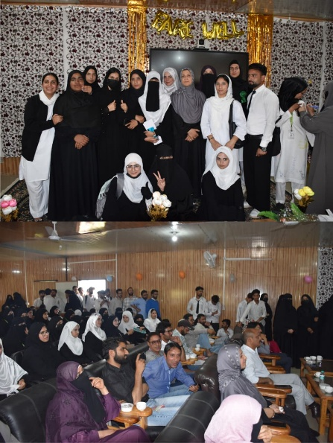

Media Secretary,
HKM Degree College Bandipora

