Registration on PMIS Portal HKM Degree College, Bandipora
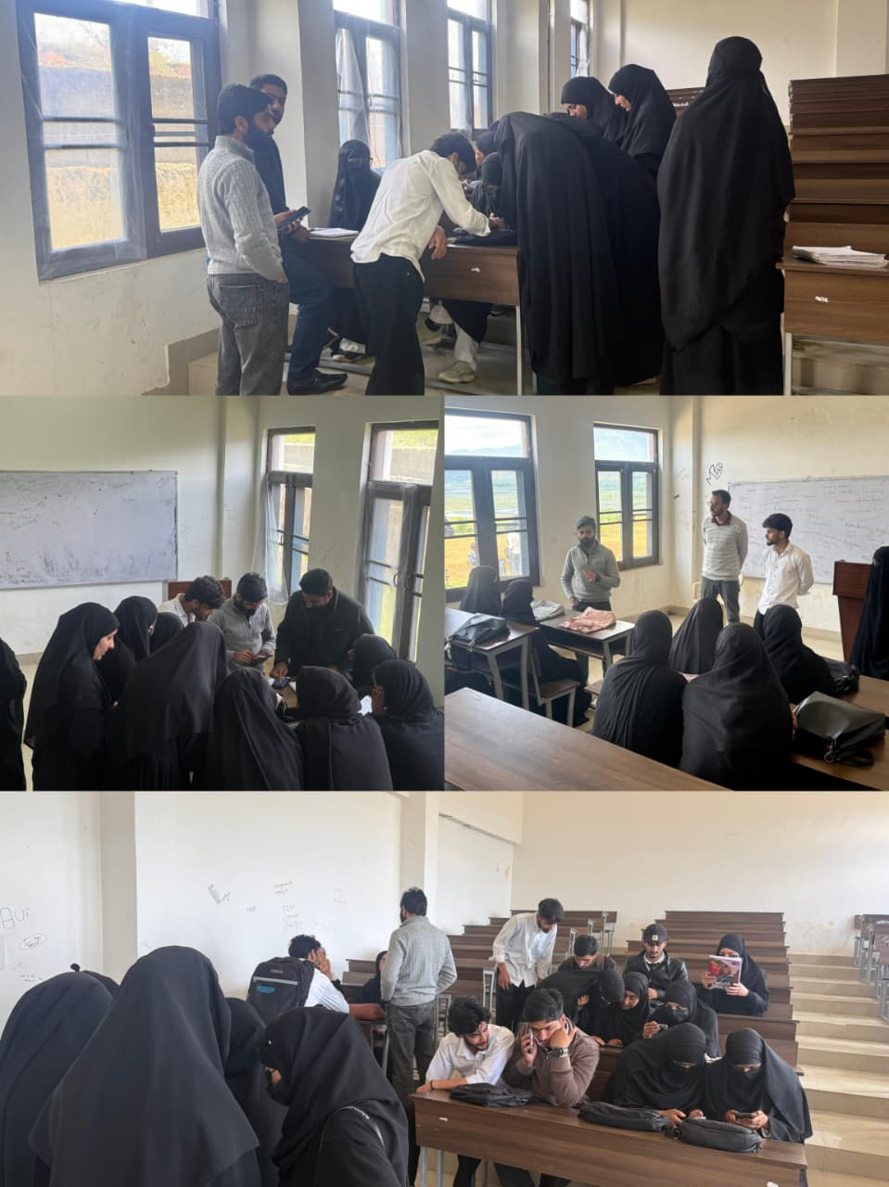
Under the dynamic leadership of the worthy Principal, Prof. Suresh Kumar Dogra, a registration drive on the Prime Minister’s Internship Scheme (PMIS) portal was successfully conducted at HKM Degree College, Bandipora on 05-05-2026. The registration process was coordinated by the Liaison Officer, Dr. Mehrajuddin Talie, for the 6th semester students belonging to the Departments of Education, Political Science and Urdu. Dr. Mehrajuddin Talie meticulously coordinated the entire process, guiding students through each step of registration, including data entry, document verification and submission protocols. Faculty members from the respective departments extended their full cooperation by mobilizing students, assisting in verification and facilitating the smooth execution of the registration process. The students actively participated and showed keen interest, ensuring that the process was completed efficiently. The registration drive was conducted in a systematic and organized manner within the college premises. Overall, the initiative was carried out successfully, achieving its intended objective of registering 6th semester students from the Departments of Education, Political Science and Urdu on the PMIS portal.

Secretary Media Cell
HKM GDC Bandipora

